**Machine Learning Sentiment Analysis**

**AIDI 1002 – Final Project**

Michael Molnar (100806823)

**Model Deployment**

<https://sentiment-analyzer-mm.herokuapp.com/>

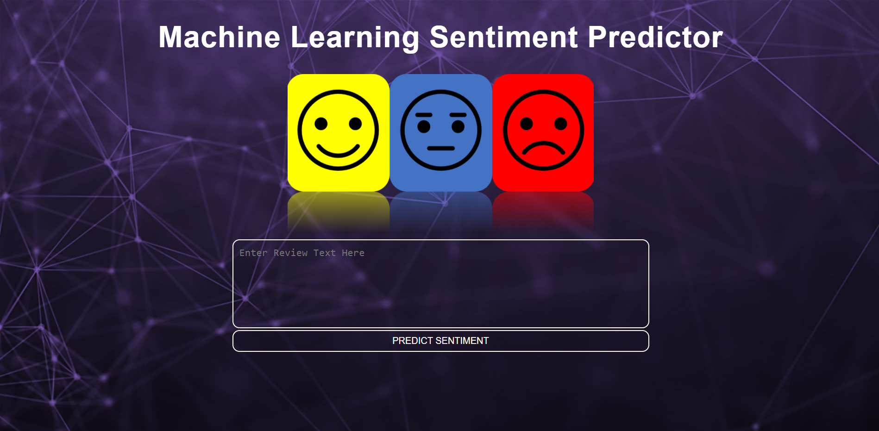

*Figure: Landing Page*

FILE DOCUMENTATION:

**model.py**

In this file I build and train my final model from Notebook 4. I import the cleaned, split, and resampled datasets and fit a Count Vectorizer with an n-gram range of one to three. I transform the data using this.

Next, I fit a Logistic Regression Classifier onto the training data. I pickle both the fit model and the fit vectorizer for use in my application.

**app.py**

In this file I use Flask to build my web application. I import my previously fit model and vectorizer and define all of the cleaning and preprocessing functions I have created to handle input text. These are:

* Expanding contractions
* Removing line breaks
* Removing punctuation and special characters
* Removing stopwords
* Lower casing all text
* Applying stemming

I create an input form for a user to enter their text. Upon pressing the “PREDICT SENTIMENT” button, the text will be processed and transformed by the previously fit vectorizer. Its predicted sentiment and the probabilities the model associates to the three classes will be generated using the previously fit Logistic Regression model.

Output will be displayed as:

* The user’s text
* The predicted sentiment
* The predicted probabilities for the three classes – positive, neutral, negative
* A bar graph showing these probabilities

**index.html**

In this file I make my app functional and stylish. I have created a simple graphic to display at the top of the page. The entire page will resize and maintain its proportions on a desktop browser or on a phone, and as the window is resized.

**Other files**

Requirements.txt, Procfile and other necessary files are placed on my Git Hub.

**Hosting**

I host the app on Heroku.

**Sample Output**

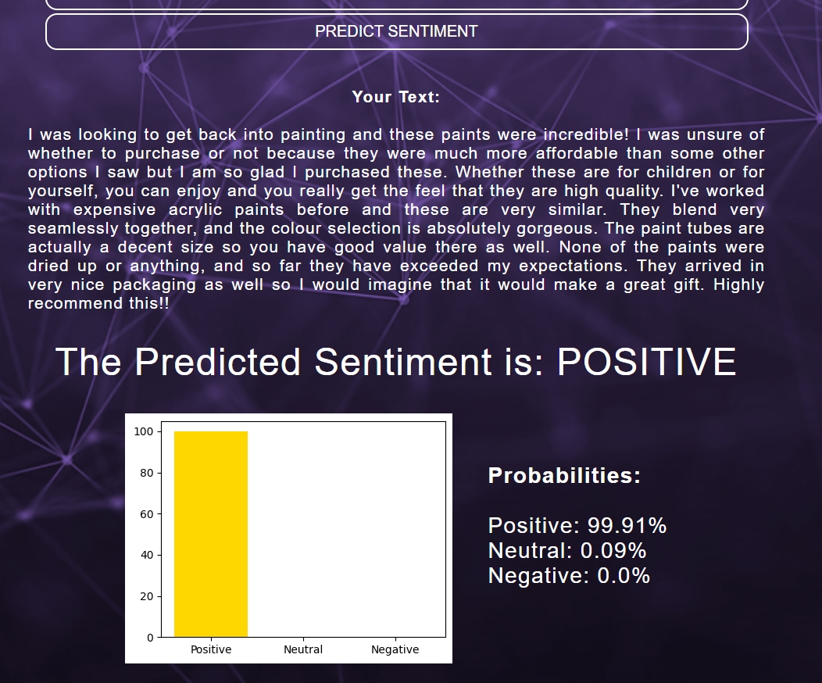

*Figure: Sample Output for a User Review*